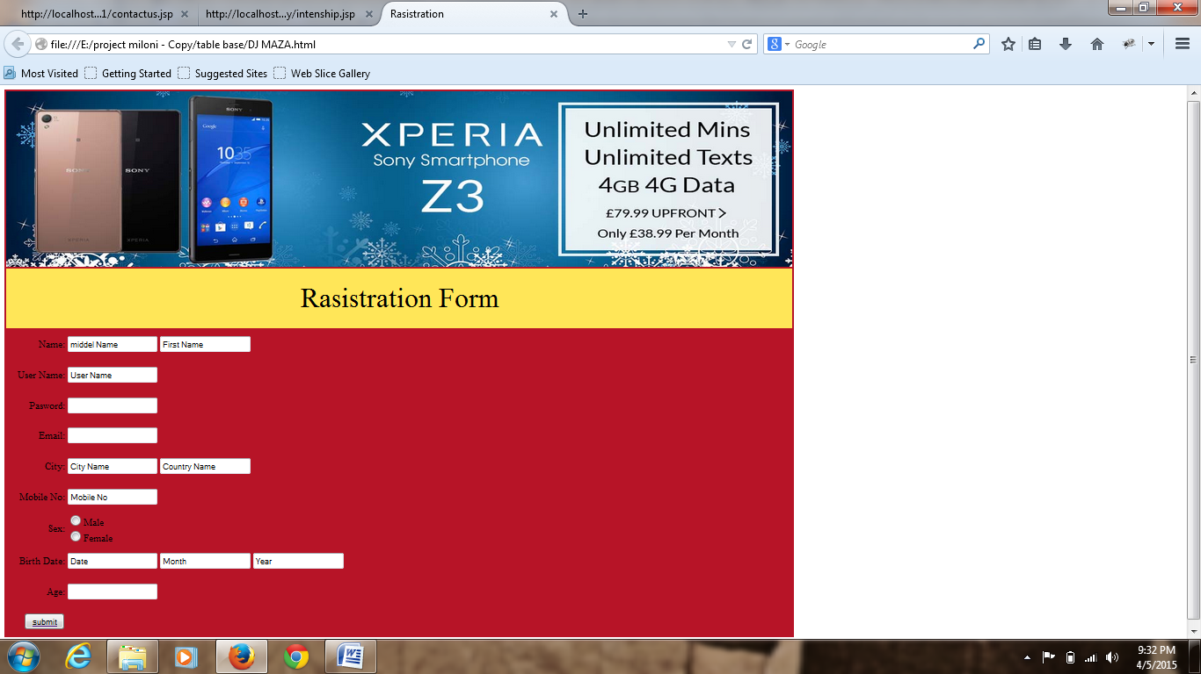

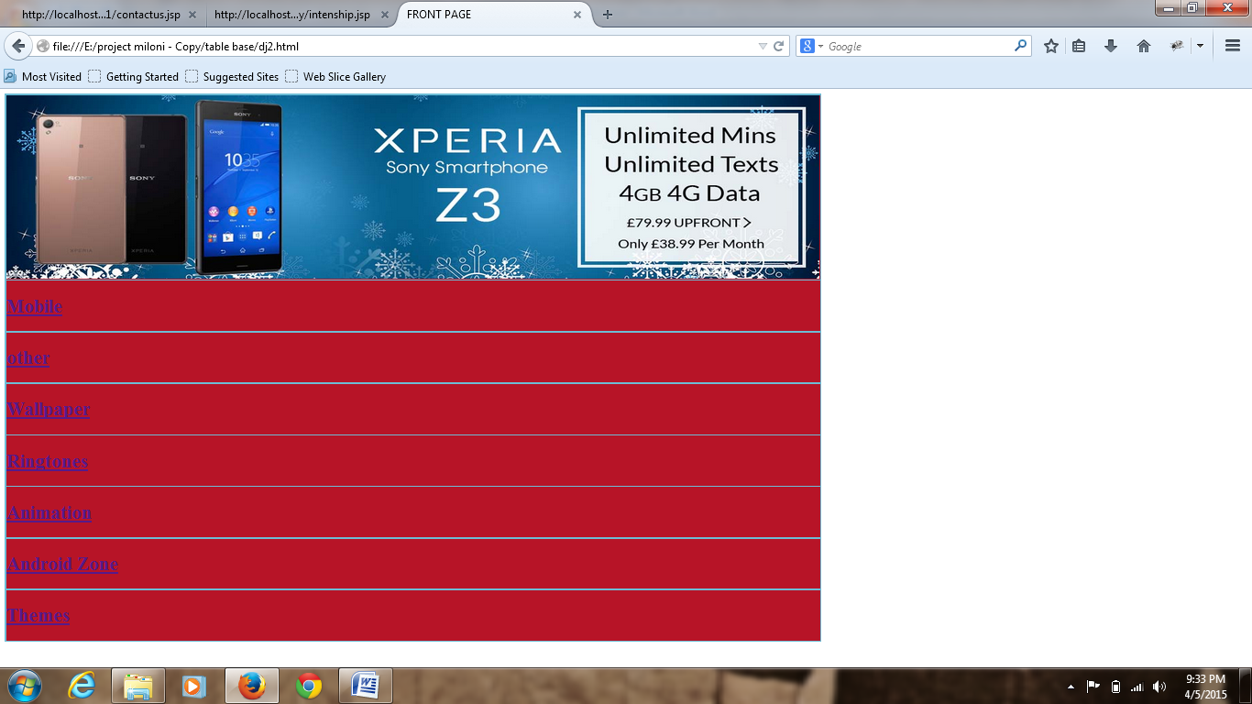

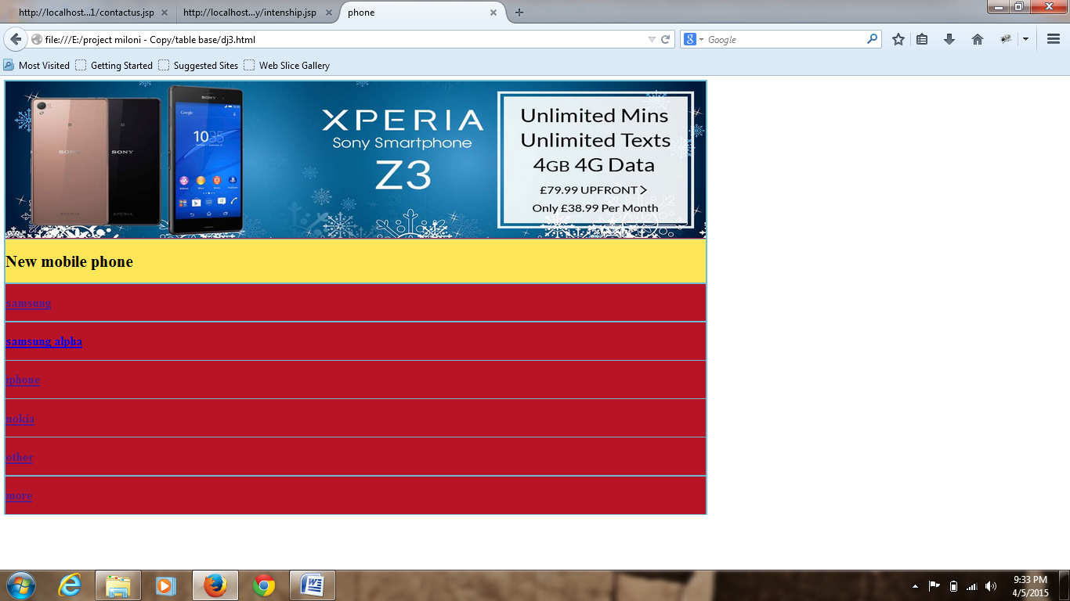

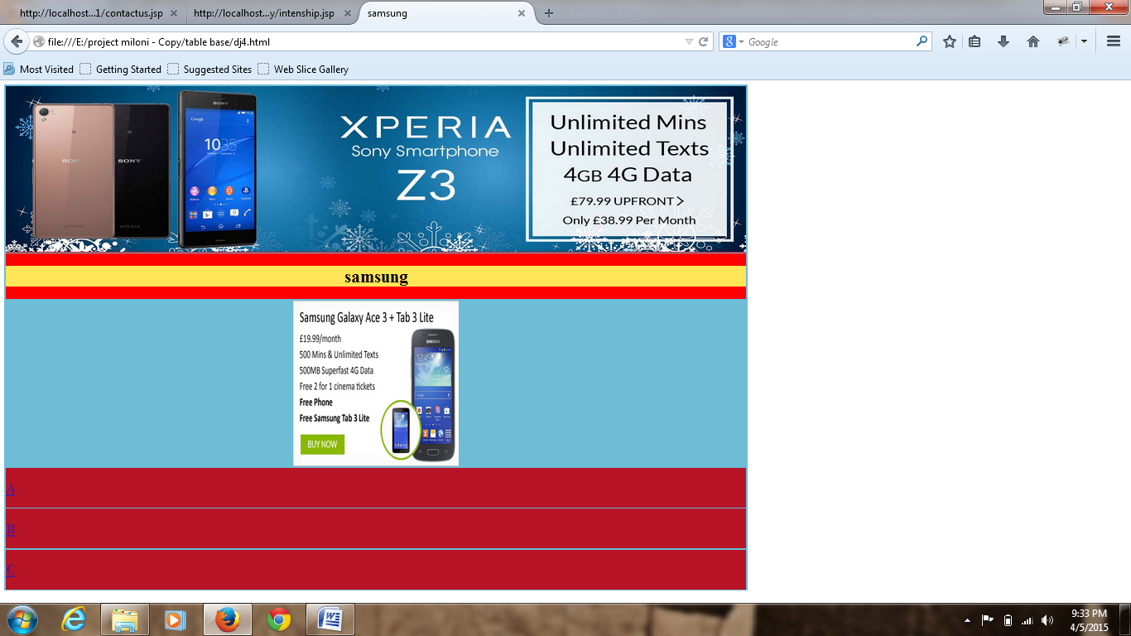

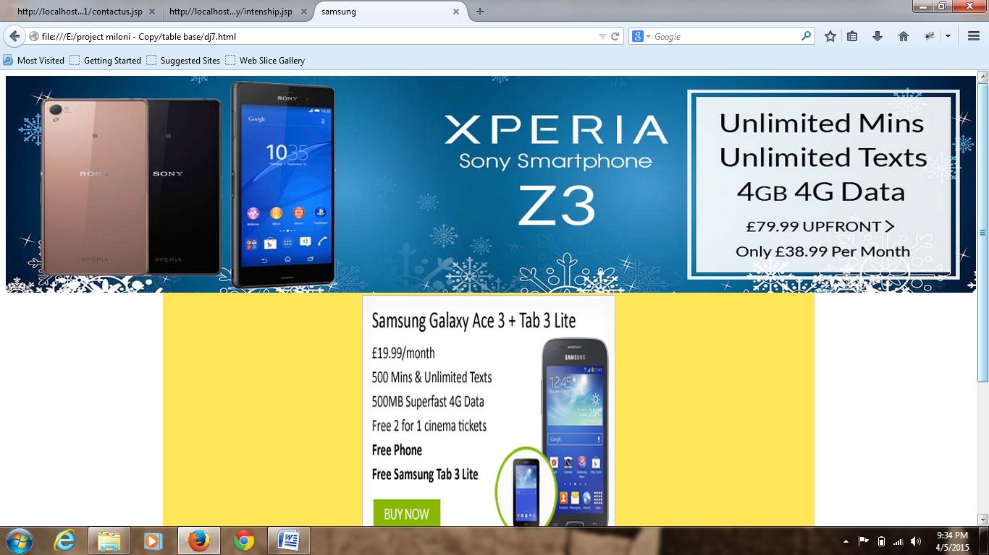

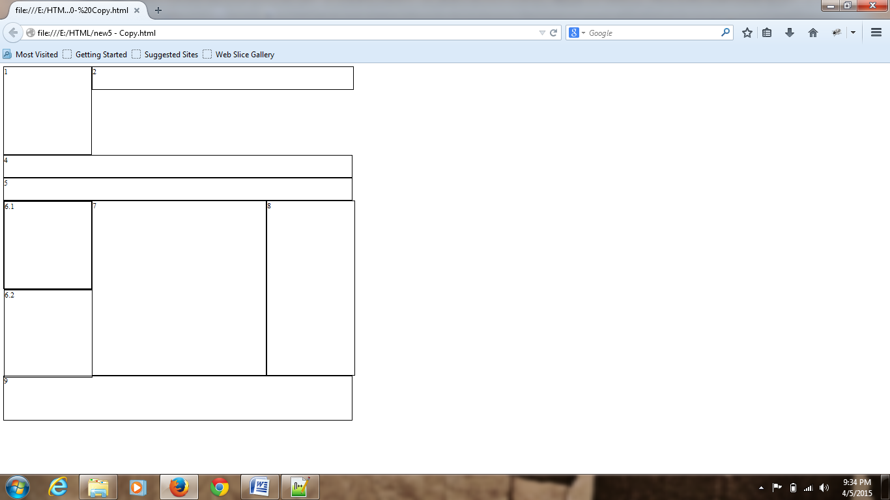

**Djmaza.html**

<!DOCTYPE html PUBLIC "-//W3C//DTD XHTML 1.0 Transitional//EN" "http://www.w3.org/TR/xhtml1/DTD/xhtml1-transitional.dtd">

<html xmlns="http://www.w3.org/1999/xhtml">

<head>

<meta http-equiv="Content-Type" content="text/html; charset=utf-8" />

<title>Rasistration</title>

</head>

<body>

<table bgcolor="#B71427" height="800" width="1340">

<form>

<tr height="300">

<td colspan="2" height="300"><img src="DJmaza/pic2.jpg"width="1340"height="300"/><br/>

</td>

</tr>

<tr height="100">

<td colspan="2" bgcolor="#FFE658" align="center" height="100"> <font style="bold" color="#000000" size="+6">Rasistration Form</font>

</td>

</tr>

<tr height="50">

<td width="100" align="Right"> Name: </td>

<td align="left"> <input type="text" value="middel Name"/> <input type="text" value="First Name"/></td>

</tr>

<tr height="50">

<td width="100" align="right"> User Name: </td>

<td align="left"> <input type="text" value="User Name"/> </td>

</tr>

<tr height="50">

<td width="100" align="right"> Pasword: </td>

<td align="left"> <input type="pasword" name="pasword"/> </td>

</tr>

<tr height="50">

<td width="100" align="right"> Email: </td>

<td align="left"> <input type="Email" name="Email"/> </td>

</tr>

<tr height="50">

<td width="100"align="Right"> City: </td>

<td align="left"> <input type="text" value="City Name"/> <input type="text" value="Country Name"/></td>

</tr>

<tr height="50">

<td width="100" align="right"> Mobile No: </td>

<td align="left"> <input type="text" value="Mobile No"/> </td>

</tr>

<tr height="50" >

<td width="100" align="right"> Sex: </td>

<td align="left"> <input type="radio"name="sex"value="male"/>Male<br/>

<input type="radio"name="sex"value="female"/>Female<br/></td>

</tr>

<tr height="50">

<td width="100" align="right"> Birth Date: </td>

<td align="left"> <input type="date" value="Date"/> <input type="date" value="Month" /> <input type="date" value="Year"/></td>

</tr>

<tr height="50" >

<td width="100" align="right"> Age: </td>

<td align="left"> <input type="text" name="Age"/> </td>

</tr>

<tr height="50">

<td width="100" align="right"><a href="dj2.html"> <input type="button" value="submit"/> </a> </td>

</tr>

</form>

</table>

</body>

</html>

**Dj2.html**

<!DOCTYPE html PUBLIC "-//W3C//DTD XHTML 1.0 Transitional//EN" "http://www.w3.org/TR/xhtml1/DTD/xhtml1-transitional.dtd">

<html xmlns="http://www.w3.org/1999/xhtml">

<head>

<meta http-equiv="Content-Type" content="text/html; charset=utf-8" />

<title>FRONT PAGE</title>

</head>

<body>

<table width="1330" height="450" bgcolor="#6DBDD6">

<tr height="300" bgcolor="#B71427" >

<td colspan="2" height="300"><img src="DJmaza/pic2.jpg"width="1330"height="300"/><br/>

</tr>

<tr height="55" bgcolor="#B71427">

<td><h1 style="background-color:#B71427"><a href="dj3.html">Mobile</a></h1></td>

</tr>

<tr height="55"bgcolor="#B71427">

<td><h1 style="background-color:#B71427"><a href>other</a></h1></td>

</tr>

<tr height="55" bgcolor="#B71427">

<td><h1 style="background-color:#B71427"><a href>Wallpaper</a></h1></td>

</tr>

<tr height="55" bgcolor="#B71427">

<td><h1 style="background-color:#B71427"><a href>Ringtones</a></h1></td>

</tr>

<tr height="55" bgcolor="#B71427">

<td><h1 style="background-color:#B71427"><a href>Animation</a></h1></td>

</tr>

<tr height="55" bgcolor="#B71427">

<td><h1 style="background-color:#B71427"><a href>Android Zone</a></h1></td>

</tr>

<tr height="55" bgcolor="#B71427">

<td><h1 style="background-color:#B71427"><a href>Themes</a></h1></td>

</tr>

</table>

</body>

</html>

**Dj3.html**

<!DOCTYPE html PUBLIC "-//W3C//DTD XHTML 1.0 Transitional//EN" "http://www.w3.org/TR/xhtml1/DTD/xhtml1-transitional.dtd">

<html xmlns="http://www.w3.org/1999/xhtml">

<head>

<meta http-equiv="Content-Type" content="text/html; charset=utf-8" />

<title>phone</title>

</head>

<body>

<table width="1340" height="450" bgcolor="#6DBDD6">

<tr height="300" bgcolor="#B71427" >

<td colspan="2" height="300"><img src="DJmaza/pic2.jpg"width="1340"height="300"/><br/>

</tr>

<tr height="50" bgcolor="#FFE658">

<td height="50"><h1 style="background-color:#FFE658">New mobile phone</h1></td>

</tr>

<tr height="20" bgcolor="#B71427">

<td><h2 style="background-color:#B71427"><a href="dj4.html">samsung</a></h2></td>

</tr>

<tr height="20"bgcolor="#B71427">

<td><h2 style="background-color:#B71427"><a href="dj5.html">samsung alpha</a></h2></td>

</tr>

<tr height="20" bgcolor="#B71427">

<td><h2 style="background-color:#B71427"><a href>iphone</a></h2></td>

</tr>

<tr height="20" bgcolor="#B71427">

<td><h2 style="background-color:#B71427"><a href>nokia</a></h2></td>

</tr>

<tr height="20" bgcolor="#B71427">

<td><h2 style="background-color:#B71427"><a href>other</a></h2></td>

</tr>

<tr height="20" bgcolor="#B71427">

<td><h2 style="background-color:#B71427"><a href>more</a></h2></td>

</tr>

</table>

</body>

</html>

**dj5.html**

<!DOCTYPE html PUBLIC "-//W3C//DTD XHTML 1.0 Transitional//EN" "http://www.w3.org/TR/xhtml1/DTD/xhtml1-transitional.dtd">

<html xmlns="http://www.w3.org/1999/xhtml">

<head>

<meta http-equiv="Content-Type" content="text/html; charset=utf-8" />

<title>samsung alpha</title>

</head>

<body>

<table width="1340" height="450" bgcolor="#6DBDD6">

<tr height="300" bgcolor="#B71427" >

<td colspan="2" height="300">

<img src="DJmaza/pic2.jpg" width="1340" height="300"/><br/>

</td>

</tr>

<tr height="50" bgcolor="#FFE658">

<td height="50"><h1 style="background-color:#FFE658" align="center">samsung alpha</h1></td>

</tr>

<tr height="300">

<td colspan="2" height="300" align="center">

<img src="DJmaza/Sooraj Dooba Hai - Front.jpg" width="300" height="300"/><br/>

</td>

</tr>

<tr height="20" bgcolor="#B71427">

<td><h2 style="background-color:#B71427"><a href="dj8.html">a</a></h2></td>

</tr>

<tr height="20"bgcolor="#B71427">

<td><h2 style="background-color:#B71427"><a href="dj9.html">b</a></h2></td>

</tr>

<tr height="20" bgcolor="#B71427">

<td><h2 style="background-color:#B71427"><a href>c</a></h2></td>

</tr>

</table>

</body>

</html>

**Dj9.html**

<!DOCTYPE html PUBLIC "-//W3C//DTD XHTML 1.0 Transitional//EN" "http://www.w3.org/TR/xhtml1/DTD/xhtml1-transitional.dtd">

<html xmlns="http://www.w3.org/1999/xhtml">

<head>

<meta http-equiv="Content-Type" content="text/html; charset=utf-8" />

<title>samsung alpha</title>

</head>

<body>

<img src="DJmaza/pic2.jpg" alt="fp"width="1340"height="300"/><br/>

<table bgcolor="#FFE658" height="500" width="900" align="center" >

<tr height="300" >

<td colspan="3" bgcolor="#FFE658" bordercolor="#FF0000" align="center">

<img src="DJmaza/Chittiyaan Kalaiyaan - Front.jpg" width="350"height="350" align="center"/><br/>

</td>

</tr>

<tr height="100">

<td colspan="3" width="300" height="100" align="center"> <font style="bold" color="#CC3333" size="+6">

C</font>

</td>

</tr>

<tr height="100" bgcolor="#FFCC00">

<td colspan="3" bgcolor="#FFCC00" bordercolor="FFCC00" width="300" height="100"align="center"><a href>

<font style="bold" color="#CC0000" size="+6">D</font></a> </td>

</tr>

</table>

</body>

</html>